22.21: Outside each sphere the electric field is the same as if all the charge of the sphere were at its center, and the point where we are to calculate 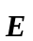 is outside both spheres. 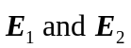 are both toward the sphere with negative charge.
